**NANDHA ENGINEERING COLLEGE**

**(Autonomous Institution)**

Erode-638 052



**TABLEAU-TWO CREDIT COURSE**

**IV – Semester**

**B.Tech - Artificial Intelligence and Data Science**

**NAME : MONIKA B R**

**BRANCH : B.TECH AI & DS**

**YEAR : II**

### **What is Tableau?**

**Tableau** is a powerful data visualization and business intelligence tool that allows users to create interactive and shareable dashboards. It helps in simplifying raw data into an understandable format without requiring technical or programming skills.

**Why Use Tableau?**

* Fast and easy data visualization.
* Ability to handle large amounts of data.
* Supports mobile-friendly dashboards.
* Strong community support and extensive learning resources.

### **Project Overview**

### **Global Road Accidents Data Analysis**

**Objective:**

The goal of this project was to analyze global road accident data to uncover patterns and insights that can help in understanding accident trends and improving road safety measures.

**Data Source:**

The data used in this project was sourced from Kaggle's "Global Road Accidents Dataset," which provides comprehensive information about road accidents worldwide, including variables such as accident location, severity, time of occurrence, weather conditions, and more.

**NUMBER OF ACCIDENTS BY REGION**

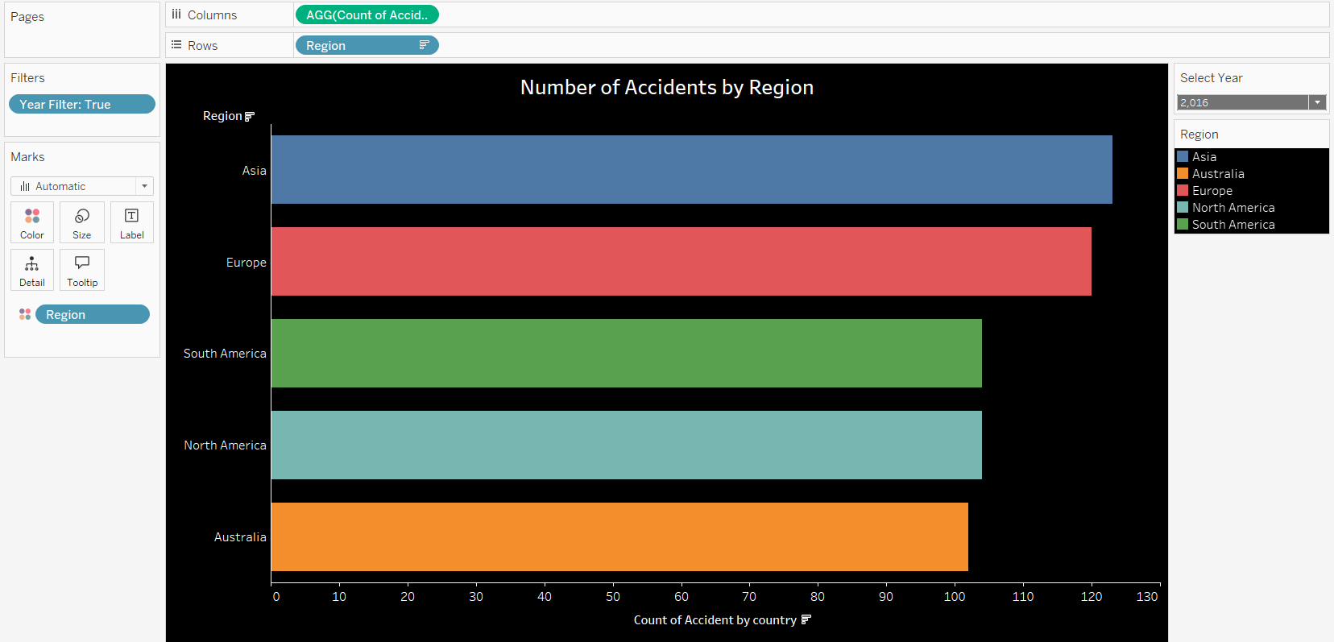

This bar chart shows the total number of accidents by region, with the data filtered by year using a parameter.

**Year Filter**: The parameter at the top lets users select a specific year. Once selected, the chart updates to show the total number of accidents for each region in that year. This feature helps to analyze trends in accident rates over time.

**Regions (X-Axis)**: The x-axis displays the different regions (countries, states, or other geographical groupings). Each region is represented by a bar on the chart.

**Accidents (Y-Axis)**: The y-axis shows the total number of accidents for each region. The height of each bar corresponds to the accident count, making it easy to compare accident rates between regions.

**Color Coding**: Each region is assigned a distinct color, allowing for quick visual differentiation between regions. This color coding makes it easier to spot trends and compare accident totals at a glance.

This chart provides a clear, interactive way to explore accident data, helping to identify regions with higher or lower accident rates for a specific year and offering insights for improving road safety.

**Number of Fatalities by Country**

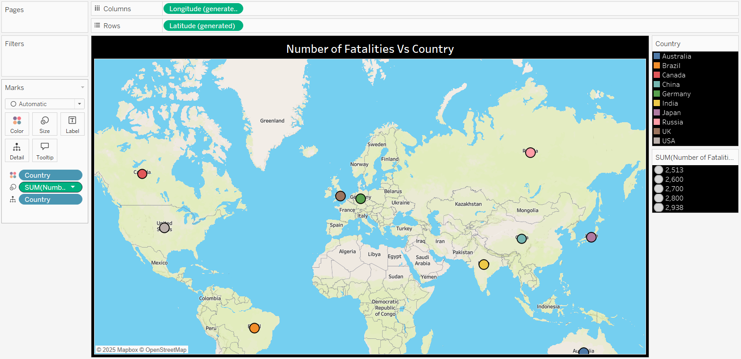

This map chart shows the number of fatalities from road accidents in different countries, with each country color-coded based on its total fatalities.

**Color Coding**: Countries are colored according to the number of fatalities. Darker colors represent higher fatalities, while lighter colors indicate fewer fatalities.

**Countries**: The map displays all countries, and the color of each country reflects its accident fatality rate.

**Interactive Tooltips**: Hovering over a country will show the exact number of fatalities for that country.

**URL Action**: When a user clicks on a country, the **URL action** takes them directly to the corresponding Wikipedia page for that country, providing more detailed information about the country, including history, geography, and other relevant facts.

This map chart helps easily compare road fatalities by country and identify regions with high or low fatality rates.

**Number of Injuries vs. Number of Fatalities by Region and Country**

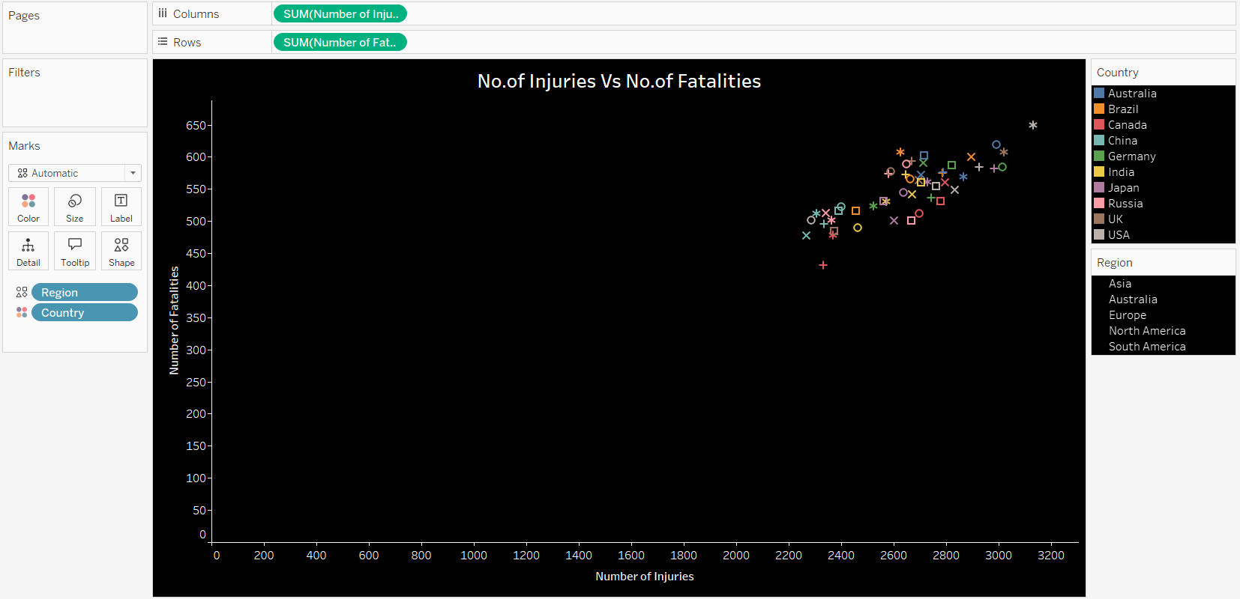

This scatter plot visualizes the relationship between the number of injuries and fatalities from road accidents, with regions represented by shape and countries color-coded.

**X-Axis (Number of Injuries)**: The x-axis represents the total number of injuries in each country. This allows for comparison across countries in terms of injury rates.

**Y-Axis (Number of Fatalities)**: The y-axis shows the total number of fatalities in each country. By plotting fatalities against injuries, the scatter plot reveals how these two variables are related across countries.

**Region (Shape)**: Each data point on the scatter plot is assigned a unique shape to represent the region of the country. For example, circles might represent one region, squares another, and triangles yet another. This helps differentiate regions visually within the plot.

**Country (Color)**: The color of each data point corresponds to the country’s accident fatality rate. Countries with higher fatalities might be shown in darker colors, while countries with lower fatalities are represented in lighter colors. This color coding helps identify patterns related to fatalities.

**Total Accidents vs. Weather Conditions**

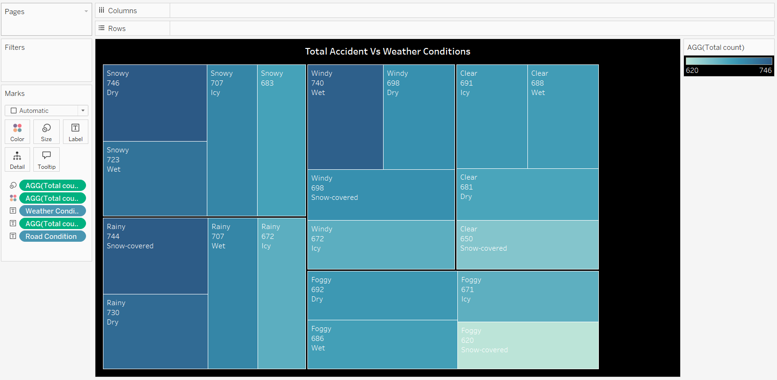

This heat map visualizes the relationship between the total number of accidents and weather conditions, highlighting the intensity of accidents under different weather conditions.

**X-Axis (Weather Conditions)**: The x-axis lists different weather conditions, such as clear, rainy, foggy, snowy, etc.

**Y-Axis (Total Accidents)**: The y-axis shows different regions or time periods (e.g., by year or by region) depending on how the data is structured.

**Color Intensity**: The cells in the heat map are colored based on the number of accidents, with darker or more intense colors representing higher accident totals and lighter colors indicating fewer accidents. This helps quickly identify which weather conditions are associated with more accidents.

**Insights**: The heat map allows users to easily spot weather conditions that contribute to higher accident totals, making it easier to analyze how weather impacts road safety across different regions or time periods.

**Total Number of Insurance Claims vs. Year by Region**

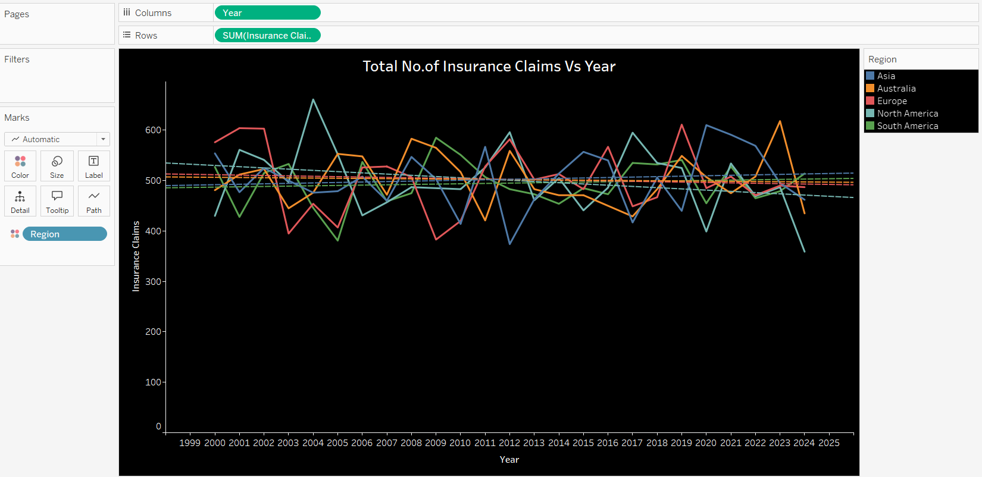

This line chart shows the trend of insurance claims over the years, with each region represented by a different color.

**X-Axis (Year)**: The x-axis shows the timeline (years), allowing users to track changes over time.

1. **Axis (Total Number of Insurance Claims)**: The y-axis shows the total number of insurance claims filed each year.

**Region (Color)**: Each region is represented by a different colored line, making it easy to compare trends between regions.

**Insights**: The chart helps users identify how insurance claims have increased or decreased over time in different regions, and spot patterns such as sudden spikes or drops.

**Accident Event Clusters: Vehicles Involved vs. Response Time**

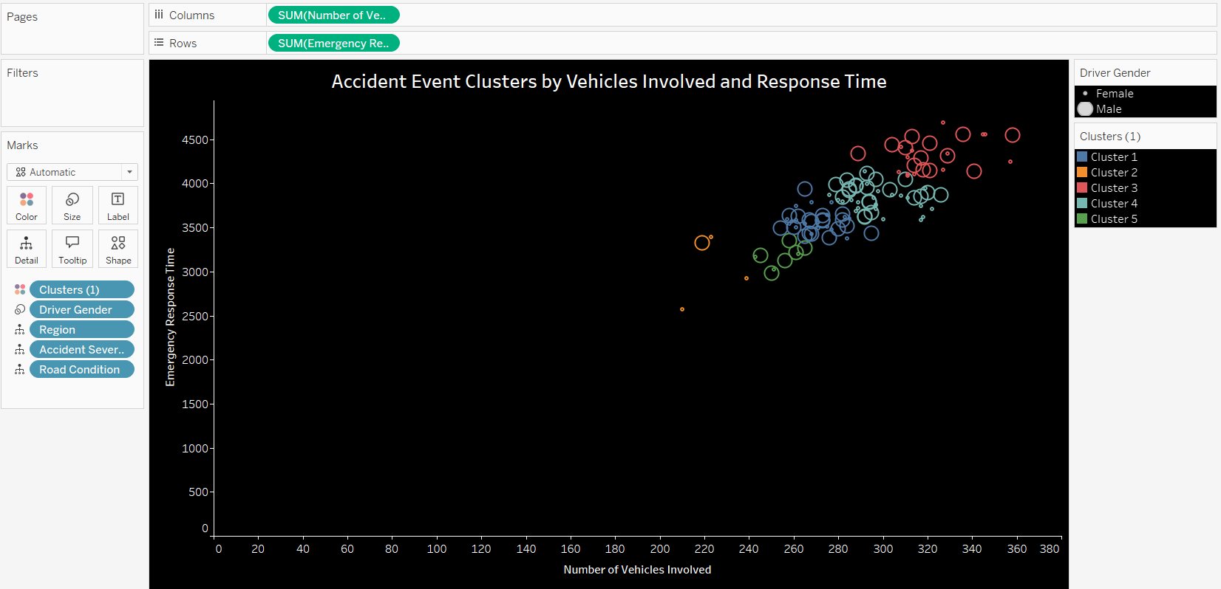

This visualization groups accident events into clusters based on the number of vehicles involved and the emergency response time, while showing extra details like gender and region.

**X-Axis (Vehicles Involved)**: The x-axis shows the number of vehicles involved in each accident event.

**Y-Axis (Response Time)**: The y-axis shows the emergency response time (how quickly help arrived after the accident).

**Cluster Size**: The size of each cluster (or bubble) represents the number of accidents in that group — larger clusters mean more accident events with similar conditions.

**Gender (Details)**: When you hover over a cluster, it shows detailed information like the gender of people involved (male, female, etc.).

**Region (Color or Label)**: Each region is either color-coded or labeled, so you can easily see where different accident patterns are happening.

**Insights**: This chart helps to find patterns, like whether accidents with more vehicles tend to have longer or shorter response times, and how gender or region factors into these events.

**Road Type vs. Traffic Volume**

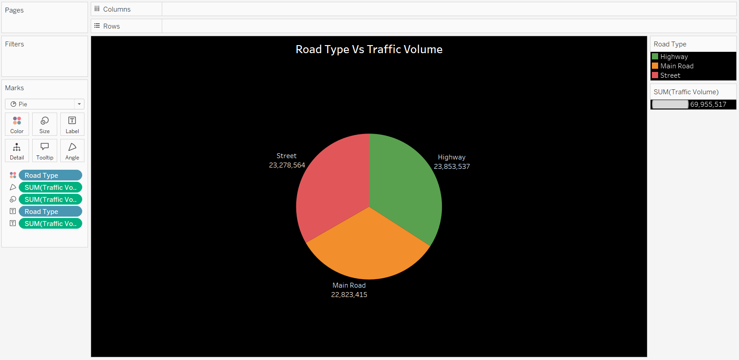

This pie chart shows how traffic volume is distributed across different road types, with each road type represented by a different color and total accidents shown in the labels.

**Road Type (Color)**: Each slice of the pie is colored differently to represent a specific road type, such as highways, city roads, or rural roads.

**Traffic Volume (Size of Slice)**: The size of each slice represents the traffic volume for that road type — larger slices mean higher traffic.

**Total Accidents (Label)**: Each slice also displays the total number of accidents that occurred on that road type, making it easy to see not just traffic volume but also accident numbers.

**Insights**: The chart helps users quickly identify which road types have the highest traffic and accident counts.

**Accidents Over Time by Day of the Week and Severity**

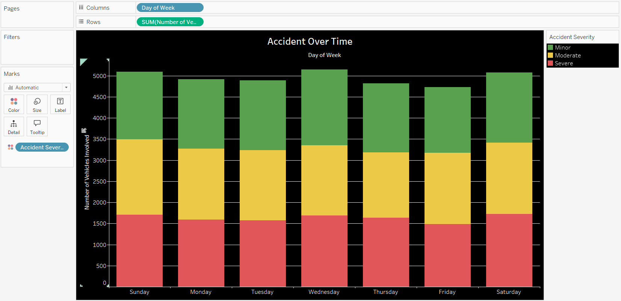

This stacked chart shows how accidents are distributed over different days of the week, with accident severity shown in different colors.

**X-Axis (Day of the Week)**: The x-axis displays the days of the week, from Monday to Sunday.

**Y-Axis (Number of Accidents)**: The y-axis shows the total number of accidents that occurred on each day.

**Accident Severity (Color)**: Each stack is divided into different colors based on accident severity levels (for example, minor, serious, or fatal accidents), helping to see the breakdown clearly.

**Insights**: The chart helps users understand which days have more accidents and how severe the accidents tend to be on different days.

**Gender vs. Total Accidents**

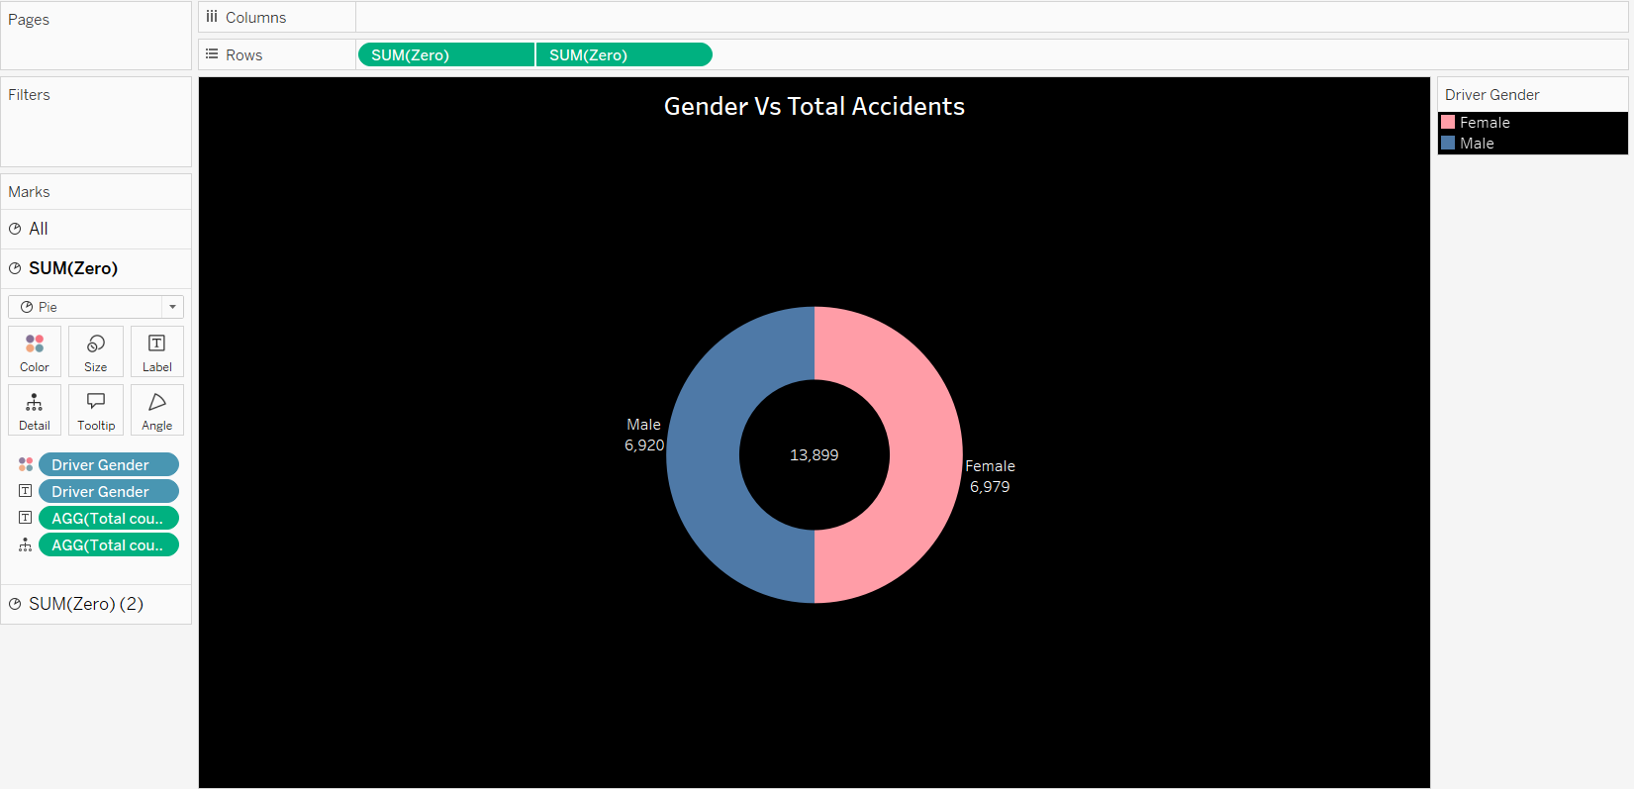

This donut chart shows the distribution of total accidents based on gender.

**Gender (Segments)**: Each segment of the donut represents a gender category, such as male, female, or others.

**Total Accidents (Size of Segments)**: The size of each segment shows the number of accidents associated with that gender — bigger segments mean more accidents.

**Color Coding**: Different colors are used for each gender to make the chart easy to read and compare.

**Insights**: This chart quickly shows which gender is involved in more accidents.

**Dashboard 1: Global Road Accidents**

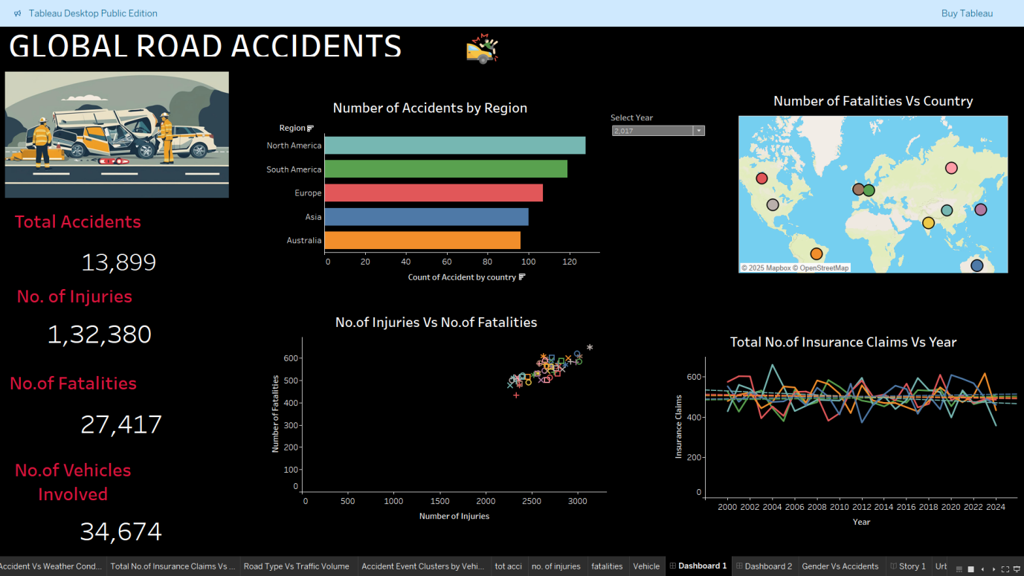

This dashboard provides a complete view of global road accident trends and key statistics:

**Summary Figures**: On the left, key numbers like **Total Accidents**, **Number of Injuries**, **Number of Fatalities**, and **Number of Vehicles Involved** are clearly highlighted.

**Number of Accidents by Region**: A bar chart shows accident counts across regions, with a year filter to see data for a selected year.

**Number of Fatalities vs. Country**: A map visualizes fatalities by country, making it easy to see where accidents are most severe.

**No. of Injuries vs. No. of Fatalities**: A scatter plot compares injuries and fatalities, using region shapes and country colors to show patterns.

**Total No. of Insurance Claims vs. Year**: A line chart tracks insurance claim trends over the years, color-coded by region for easy comparison.

**Design**: A clean dark background with colorful charts makes the information easy to read and visually attractive.

**Dashboard 2 : Global Road Accidents**

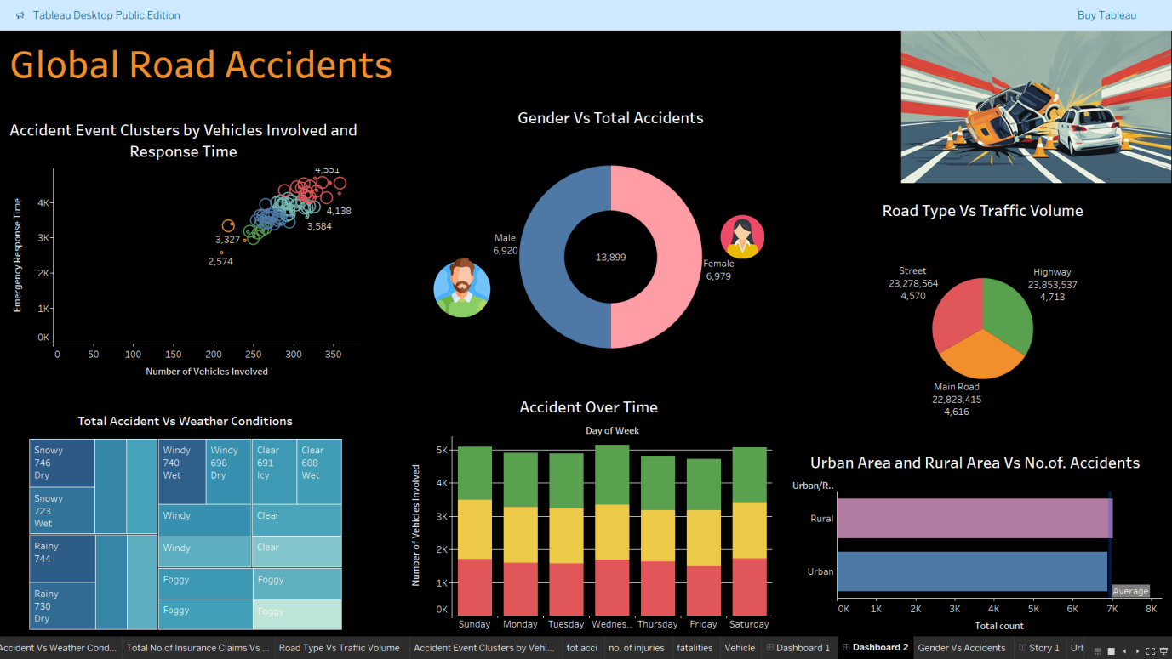

This dashboard shows deeper insights into road accident patterns using different types of charts:

**Accidents Over Time**: A stacked bar chart showing accidents by **Day of the Week** and **Accident Severity** (colored by severity levels), helping identify which days are more dangerous and how severe the accidents are.

**Road Type vs. Traffic Volume**: A **pie chart** colored by **road type**, showing how traffic is distributed across different road categories.

**Gender vs. Total Accidents**: A **donut chart** showing the distribution of accidents based on **gender**, with each gender category in different colors.

**Accident Event Clusters**: A **cluster chart** based on **Vehicles Involved** and **Response Time**, where cluster size shows the number of accidents, and hovering reveals **gender** and **region** details.

**Accident vs Weather Conditions**: A **heat map** showing the number of accidents under different **weather conditions**, with darker colors indicating higher accident counts.

**Conclusion**

The analysis of the Global Road Accidents dataset reveals key patterns that can help improve road safety worldwide. North America and South America reported the highest number of accidents, highlighting the need for stronger traffic management and safety campaigns. Fatality data showed that some countries have a higher death rate compared to injuries, suggesting gaps in emergency response systems.

The data indicates that weekends see a rise in accidents, likely due to increased travel and driver fatigue. Weather conditions, especially rain and fog, were linked to a higher number of accidents, emphasizing the importance of promoting safe driving during bad weather and improving road infrastructure.

Highways and major roads, which carry heavy traffic, also reported more accidents, pointing to the need for better traffic control and speed management. Gender analysis showed that males are more frequently involved in accidents, suggesting a need for targeted road safety education.

Insurance claim trends remained stable over time but varied between regions, indicating differences in accident risk factors across the world.

Overall, this dashboard provided clear visual insights into accident trends and helped identify critical areas for safety improvement. These findings can support better planning, stricter regulations, and more effective emergency responses to save lives and reduce accidents.